# [**'Law & Order: SVU': The Best Dr. Warner Episodes Ahead of Her Season 22 Return**](https://www.tvinsider.com/gallery/law-order-svu-season-22-warner-returning-best-episodes/amp/?__twitter_impression=true&s=09)

Maria Morava [Maria Morava](https://www.tvinsider.com/author/maria-morava/)

4 days ago

F,{f8bae39a-1df0-4dbc-b60b-46682f3cf80b}{67},3.125,3.125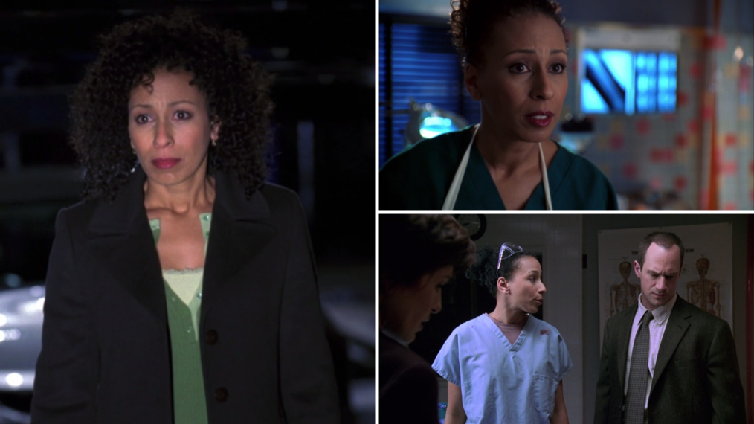

As [*Law & Order: SVU*](https://www.tvinsider.com/show/law-order-svu/) ramps up production for its historic 22nd season, a certain medical examiner known for her quips and plot-twisting discoveries returns.

[Tamara Tunie](https://www.tvinsider.com/people/tamara-tunie/) shared the news via Instagram on September 17 with the caption, “And Season 22 begins! And DR. WARNER is BACK!!! So happy and full of thanks, to be working!!”

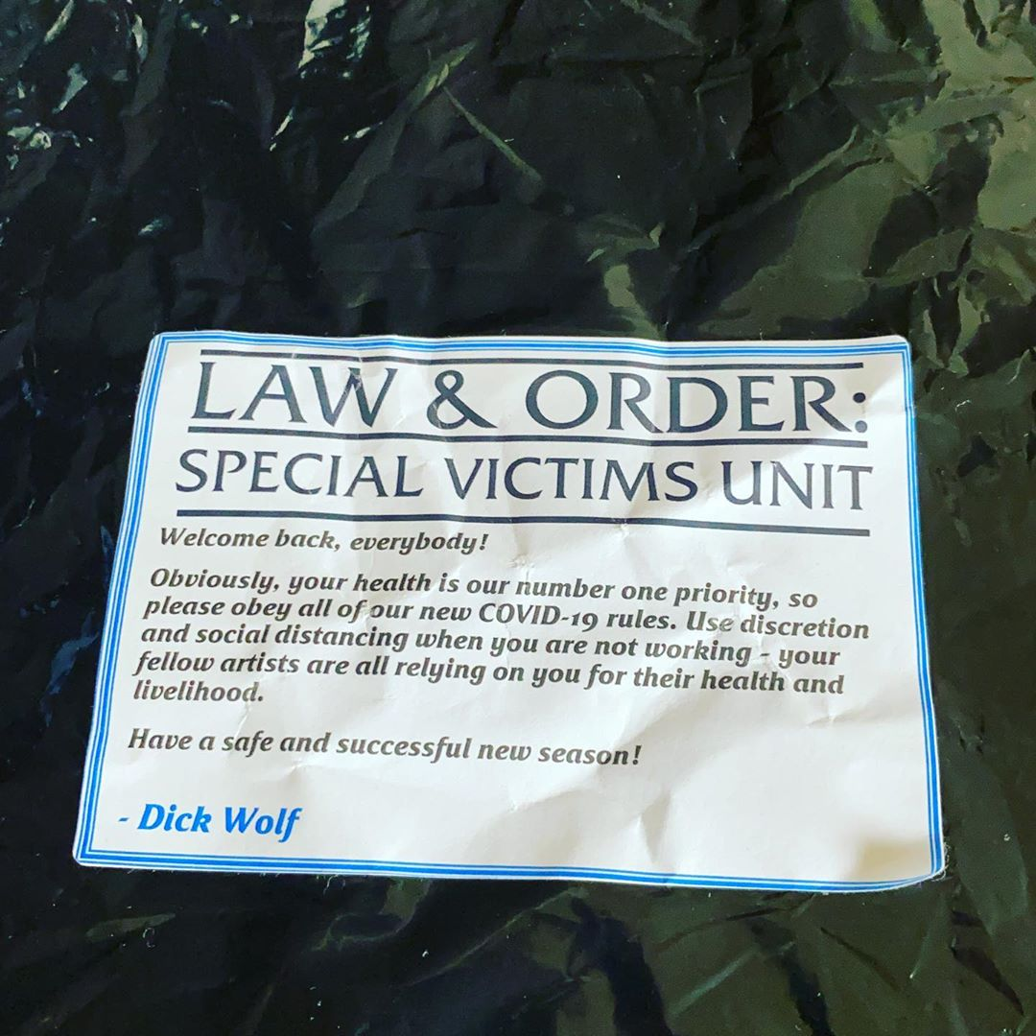

Earlier this year, we got the news that Elliot Stabler ([Christopher Meloni](https://www.tvinsider.com/people/christopher-meloni/)) would return to the *Law & Order* universe in his own spinoff, [*Law & Order: Organized Crime*](https://www.tvinsider.com/show/law-order-organized-crime/), and we have been waiting anxiously for his reunion with his former partner, the now-Captain Olivia Benson ([Mariska Hargitay](https://www.tvinsider.com/people/mariska-hargitay/)), ever since.

It looks like we won’t see Stabler until 2021, though, and the only thing easing the pain is the return of our favorite medical examiner. Ahead of that, we are looking back at our favorite episodes featuring the best of Melinda Warner.

F,{f8bae39a-1df0-4dbc-b60b-46682f3cf80b}{124},3.125,3.125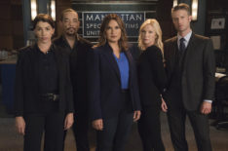[**SEE ALSO**](https://www.tvinsider.com/948902/law-order-svu-season-22-filming-photos-mariska-hargitay/)

### ['SVU' Returns to Filming: The Cast Posts From Set (PHOTOS)](https://www.tvinsider.com/948902/law-order-svu-season-22-filming-photos-mariska-hargitay/)

Mariska Hargitay and Jamie Gray Hyder have shared photos while in production in New York.

**Law & Order: SVU, Season 22 Premiere, Thursday, November 12, 9/8c, NBC**

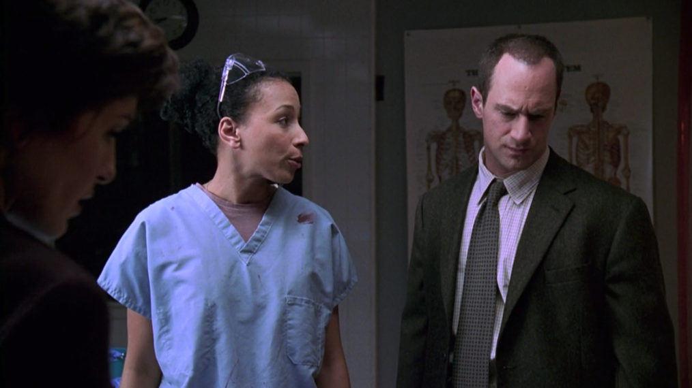

NBC

### "Noncompliance" (Season 2, Episode 6)

Warner’s first appearance on *Law & Order: SVU* is worth watching simply to feel the nostalgia of the early 2000s.

In this Season 2 episode, a psychiatric doctoral student is stabbed—and in true *SVU* fashion, the case stumbles into controversial territory.

U,{f8bae39a-1df0-4dbc-b60b-46682f3cf80b}{218},3.125,3.125

NBC

### "Blast" (Season 7, Episode 13)

In this episode, Dr. Warner finds herself involved in a child kidnapping case more intensely than she intended. Working with Stabler, she enters a tense face-off with the kidnapper.

Season 7 was Tunie’s first as a series regular, and in this episode, where we see Dr. Warner’s capabilities transcend the medical, we understand why she became a permanent fixture of the SVUniverse.

U,{cd7e3553-2a5b-4b3e-9a50-ee728eff8dfb}{1},3.125,3.125

NBC

### "Dependent" (Season 8, Episode 14)

Dr. Warner’s job is to speak for the dead. In this episode, she proves that her loyalty to her work comes first—even when Stabler’s career depends on her ruling. When Benson pushes her to sympathize with Stabler’s innocence, Dr. Warner holds her own and honors the facts.

U,{cd7e3553-2a5b-4b3e-9a50-ee728eff8dfb}{33},3.125,3.125

NBC

### "Harm" (Season 9, Episode 5)

In a heavy episode about military-sanctioned torture, Dr. Warner both advocates for her justice-oriented opinion and (of course) saves a life in the courtroom.

She also has a quippy few lines with another favorite *SVU* doctor, Dr. Huang ([BD Wong](https://www.tvinsider.com/people/bd-wong/)), in which she plays the Hippocratic Oath card (“do no harm”)—and wins.

U,{cd7e3553-2a5b-4b3e-9a50-ee728eff8dfb}{74},3.125,3.125

NBC

### "Retro" (Season 10, Episode 5)

Dr. Warner’s expertise is heavily drawn on when the SVU squad tackles a case about AIDS denial and alternative medicine. In this episode, she outwits an obnoxious defense attorney, calls an AIDS denialist a “false prophet” on the courthouse steps, and exhumes a body. “Retro” is peak Melinda Warner.

U,{cd7e3553-2a5b-4b3e-9a50-ee728eff8dfb}{106},3.125,3.125

NBC

### "Shattered" (Season 11, Episode 24)

The best thing about 2010 being over is that we never have to see Dr. Warner get shot again. We are grateful, though, that it gave us one of her most iconic lines: “Back off vultures, I’m not dead yet!”

U,{cd7e3553-2a5b-4b3e-9a50-ee728eff8dfb}{138},3.125,3.125

NBC

### "Merchandise" (Season 12, Episode 4)

In Tunie’s last season as a series regular, we were blessed with some truly great Warner lines. In this episode about a human trafficking scheme, she disarms an innocent question from Benson with, “I know how to do my job. I was shot in the lung, not the head.”

U,{cd7e3553-2a5b-4b3e-9a50-ee728eff8dfb}{170},3.125,3.125

NBC

### "Murdered at a Bad Address" (Season 21, Episode 6)

We’re preparing for Warner’s return by revisiting some of her brief cameos throughout the past few seasons. Just last season, she was the ultimate comforting presence as we learned of the death of Simon Marsden (Benson’s half-brother, played by [Michael Weston](https://www.tvinsider.com/people/michael-weston/)). We’re hoping that her Season 22 return doesn’t come with bad news!